Java Notes

Java is one of the most popular and widely used programming language and platform. A platform is an environment that helps to develop and run programs written in any programming language.

Java is fast, reliable and secure. From desktop to web applications, scientific supercomputers to gaming consoles, cell phones to the Internet, Java is used in every nook and corner.

Java is easy to learn and its syntax is simple and easy to understand. It is based on C++ (so easier for programmers who know C++). Java has removed many confusing and rarely-used features e.g., explicit pointers, operator overloading etc. Java also takes care of memory management and for that, it provides an automatic garbage collector. This collects the unused objects automatically.

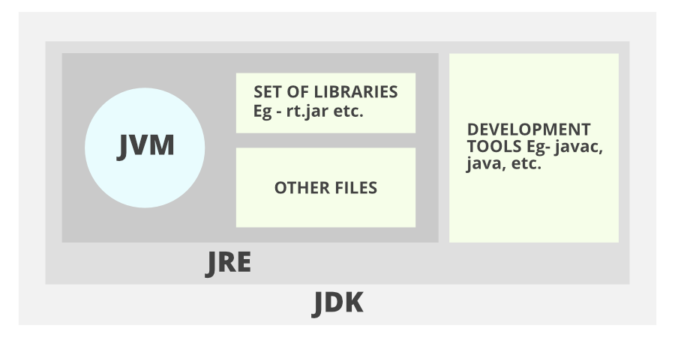

* JDK(Java Development Kit): JDK is intended for software developers and includes development tools such as the Java compiler, Javadoc, Jar, and a debugger.
* JRE(Java Runtime Environment): JRE contains the parts of the Java libraries required to run Java programs and is intended for end-users. JRE can be viewed as a subset of JDK.
* JVM: JVM (Java Virtual Machine) is an abstract machine. It is a specification that provides a runtime environment in which java bytecode can be executed. JVMs are available for many hardware and software platforms.

To Run Java Program

Java FirstProgram.java

Javac FirstProgram.class

